Let Your Intuition Take The Temperature

In the columns provided, jot down anything that comes to mind in these categories:

- Unfinished, nagging projects at home or at work
- Activities and involvements that consume lots of time and/or energy
- Ideas or dreams that you haven’t made time (yet) to pursue

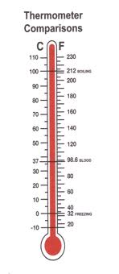

Now, for each item on your list, close your eyes and bring the item fully into your awareness using each of your main intelligence faculties: intellectual, physical, emotional, spiritual. Let yourself be fully immersed in this item. Imagine it completed or taken to the “next level”. Imagine it impacting the world around you. From this place, answer these questions:
- To what degree is this something that is yours to do?
- Ask your intuition to give you a thermometer read. Are you burning with desire or freezing in the Antarctic?
- Record its temperature
When you are finished, use the temperature of each item and your intuition around the broader vision of your life to determine how much of your precious time, attention, energy, and passion this item is to receive NOW, LATER, or NEVER.

Jeanne Loehnis, Transformational Inward Journey Life Coach
www.SongsForYourSpirit.com

