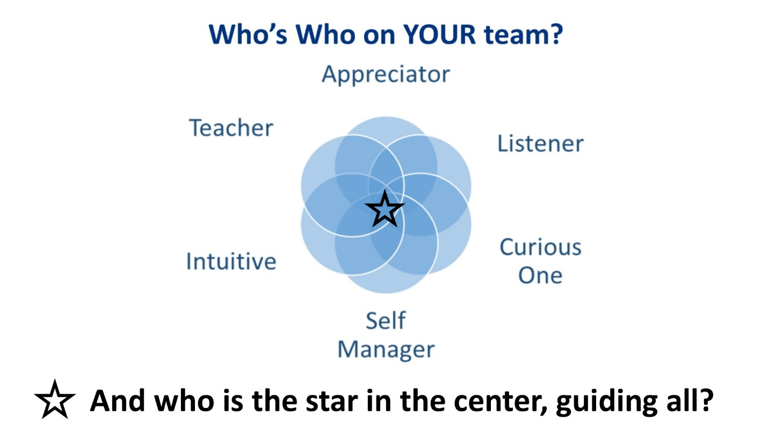
Every one of us needs support. Yes, even you! And we get it from many directions, sometimes consciously, sometimes not; sometimes positively, sometimes not. This exercise is designed to help you build your support team intentionally. Using persons or entities, living or deceased, real or imaginary, complete these seven boxes from your intuition. Let yourself settle in and allow your memories, sparks of awareness, your emotional being guide you.
Once you have your support team in place, you’ll be able to call on them whenever you need a boost. In those times, you’ll shift to your star center who will ask the appropriate team member: “What do I need to hear or remember now?” After listening for the answer, your star will guide you powerfully forward.
SUPPORT TEAM MEMBER | NAME OR ESSENCE OF MEMBER
Appreciator – appreciates everything without judgement
Teacher – shares guidance in ways we can take in
Intuitive – accesses and speaks inner knowing, values, unseen information, masterful at moving into mystery with boldness and courage
Self-Manager – maintains integrity, balance, attention, focus, timing; knows the healthy NO as well as YES
Curious One – powerful, deep curiosity, eager explorer, loves experience
Listener – witnesses with great compassion, attention; trusts that with patience, wisdom and forward motion will come
Spirit Guide – source of faith and trust, the most expansive perspective you can tune into

Finally, how do you refer to the star, the guiding force, to whom you turn as the Master of your Life? This may be a deeply held belief in God, the Universe, Spirit, Life itself. It may be your very soul, the innermost, ever-present, knowing that you sense when you slow down enough to hear.
MY STAR IS:

